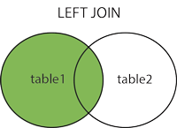

SELECT column_name(s)  
FROM table1  
LEFT JOIN table2 ON table1.column_name = table2.column_name;

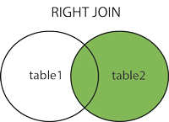

SELECT column_name(s)  
FROM table1  
RIGHT JOIN table2 ON table1.column_name = table2.column_name;

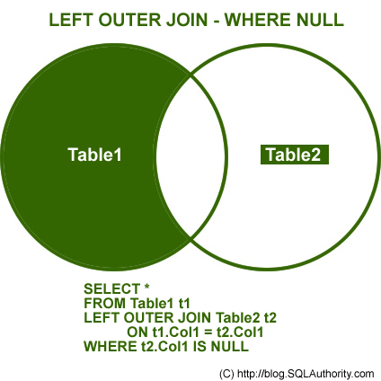

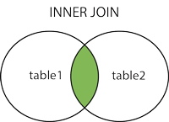

SELECT column_name(s)  
FROM table1  
INNER JOIN table2 ON table1.column_name = table2.column_name;

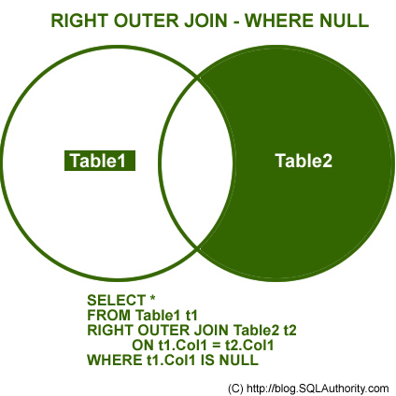

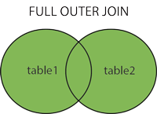

SELECT column_name(s)  
FROM table1  
FULL OUTER JOIN table2 ON table1.column_name = table2.column_name;

